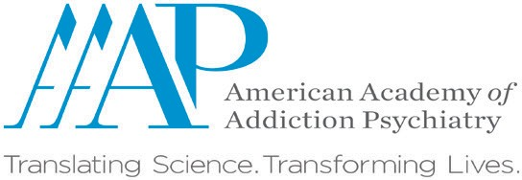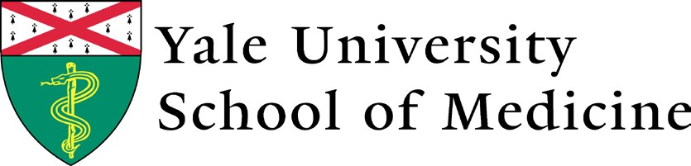

**FAQ’S:**

* How long will it take to complete courses? Approximately 9-15 hours.

If you want to know more about how to identify, diagnose and treat substance use disorder (SUDs), feel lost on how to initiate or refer people to treatment, or are just curious as to how your profession might fit in to best-practice addiction treatment, then this educational opportunity is for you.

Addiction Treatment: Clinical Skills for Healthcare Providers

Did you know?

Today, 14% of Americans have an alcohol use disorder. That’s more than 30 million people!

In 2018, more people died of a drug overdose than died from motor vehicle accidents.

The U.S. spends more on medical conditions related to substance use disorders than on diabetes treatment.

Almost 21 million Americans have at least one addiction, yet only 10% of them receive treatment.

**You are invited to participate in a pilot project that is a national, interprofessional online curriculum targeting entry-level interprofessional healthcare trainees**. Come learn from experts in the field, while sharing knowledge of your profession with learners from other disciplines! Be a part of changing how health professionals are trained about addictions.

•

•

•

6 online modules (90-120 min each)

Interactive videos, cases, and online discussion forum

Quizzes to assess knowledge and learning

**As a result you will receive:**

•

•

•

Comprehensive, interactive SUD education Interprofessional learning forums

Flexibility to learn when you want, where you want

•

•

•

Can I complete over weeks or months? It’s flexible according to your faculty/school requirements. Do I get paid to complete course? No, this is a free educational opportunity.

Am I required or expected to participate in discussions, forums, etc. or as needed? The expectation is that

participants complete the course, including assessments, and provide feedback.

**If interested in participating in the pilot contact:**

[provide faculty name ] at [school name] at [phone and/or email address]

Funding for this initiative was made possible (in part) by the Expansion of Interprofessional Healthcare Practitioner SUD Education grant #1H79FG000023 from SAMHSA. The views expressed in written conference materials or publications and by speakers and moderators do not necessarily reflect the official policies of the Department of Health and Human Services; nor does mention of trade names, commercial practices, or organizations imply endorsement by the U.S. Government.